Practical exercise: **Understanding how *APOL1* Renal Risk ‘Genotypes’ are derived**

**Purpose:**

1. To use raw genotype data to derive *APOL1* risk alleles (G0, G1 and G2) and genotypes (G0/G0, G1/G0, G2/G0, G1/G2, G1/G1 and G2/G2)
2. To understand allele and genotype frequencies
3. To understand genetic association and causality

**Background information:**

It is made up of haplotypes that involve 3 different genetic variants. Two single nucleotide variants and one indel.

Each variant is defined by a ‘rs’ number, the nucleotides involved (A/G/C/T) and the amino acid changes (S-serine; G-glycine; I-isoleucine ; M-methionine; N-asparagine; and Y-tyrosine).

Three loci that are each bi-allelic are involved

|  |  |  |
| --- | --- | --- |
| Locus | Alleles | Genotypes |
| rs73885319 | A or G | A/A or A/G or G/G |
| rs60910145 | T or G | T/T or T/G or G/G |
| rs71785313 | ins or del | ins/ins or ins/del or del/del |

Haplotypes (defined by the sequence of alleles at the three loci on a single chromosome):

|  |  |  |  |
| --- | --- | --- | --- |
| Haplotype | rs73885319  A/G  S342G | rs60910145  T/G  I384M | rs71785313  TTATAA(ins)/del  N388Y389/del |
| G0 | A | T | ins |
| G1 | G | G | ins |
| G1 | G | T | ins |
| G1 | A | G | ins |
| G2 | A | T | del |

(The other haplotypes have not been observed)

High Risk Genotypes – as usually referred to in the literature:

G0/G0, G1/G0, G2/G0, G1/G2, G1/G1 and G2/G2

Data as generated in the laboratory (either in a single genotype experiment or an array). The H3Africa array included rs73885319 and rs60910145, but not rs71785313. Therefore if using array data, rs71785313 has to be inferred (imputed) using a statistical probabilistic approach.

**Part A: Converting genotype data into APOL1 high risk ‘genotypes’**

Table 1: Raw genotypes – not phased

|  |  |  |  |
| --- | --- | --- | --- |
| Individual | rs73885319  A/G | rs60910145  T/G | rs71785313  TTATAA/del |
| ID 1 | A/A | T/T | ins/ins |
| ID 2 | A/G | T/T | ins/ins |
| ID 3 | A/A | T/T | ins/del |
| ID 4 | A/A | T/T | del/del |
| ID 5 | A/A | T/G | ins/ins |
| ID 6 | A/G | T/G | Ins/ins |
| ID 7 | A/G | T/T | Ins/del |
| ID 8 | A/G | T/T | Ins/ins |
|  |  |  |  |

Table 2: Use the data from table1 to work out the Haplotypes (2 filled in as examples – complete the rest of the table)

|  |  |  |  |  |
| --- | --- | --- | --- | --- |
| Individual | Haplotype 1 | Haplotype 2 | Diplotype | APOL1 risk ‘genotype’ |
| ID 1 | A-T-ins | A-T-ins | A-T-ins/ A-T-ins | G0/G0 |
| ID 2 | A-T-ins | G-T-ins | A-T-ins/ G-T-ins | G0/G1 |
| ID 3 |  |  |  |  |
| ID 4 |  |  |  |  |
| ID 5 |  |  |  |  |
| ID 6 |  |  |  |  |
| ID 7 |  |  |  |  |
| ID 8 |  |  |  |  |
|  |  |  |  |  |

Questions:

1. Could you resolve all the ‘genotypes’ – actually haplotypes?
2. How many individuals are ‘high risk’ *APOL1* genotypes?
3. What are the *APOL1* G0, G1 and G2 frequencies?

**Part B: Effects of APOL1 ‘genotypes’ on phenotype**

Examine the following tables and figures and answer questions

Study 1: Brandenburg JT, Govender MA, Winkler CA, Boua PR, Agongo G, Fabian J, Ramsay M. Apolipoprotein L1 High-Risk Genotypes and Albuminuria in Sub-Saharan African Populations. Clin J Am Soc Nephrol. 2022 Jun;17(6):798-808. doi:

10.2215/CJN.14321121. Epub 2022 May 16. PMID: 35577564; PMCID: PMC9269651.

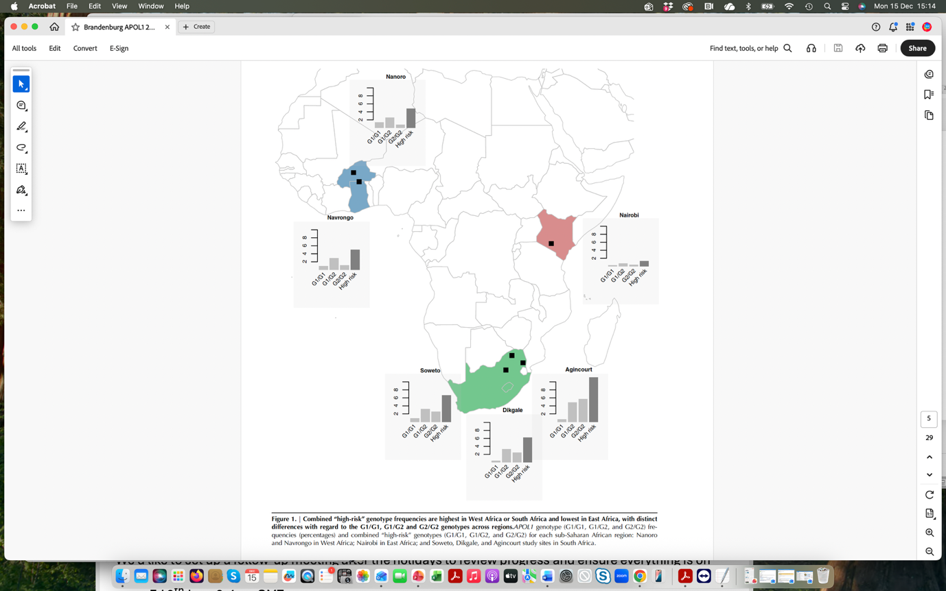

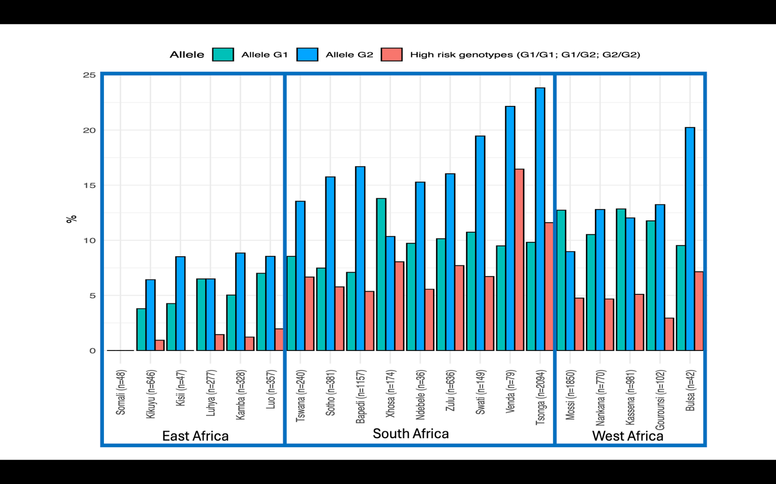

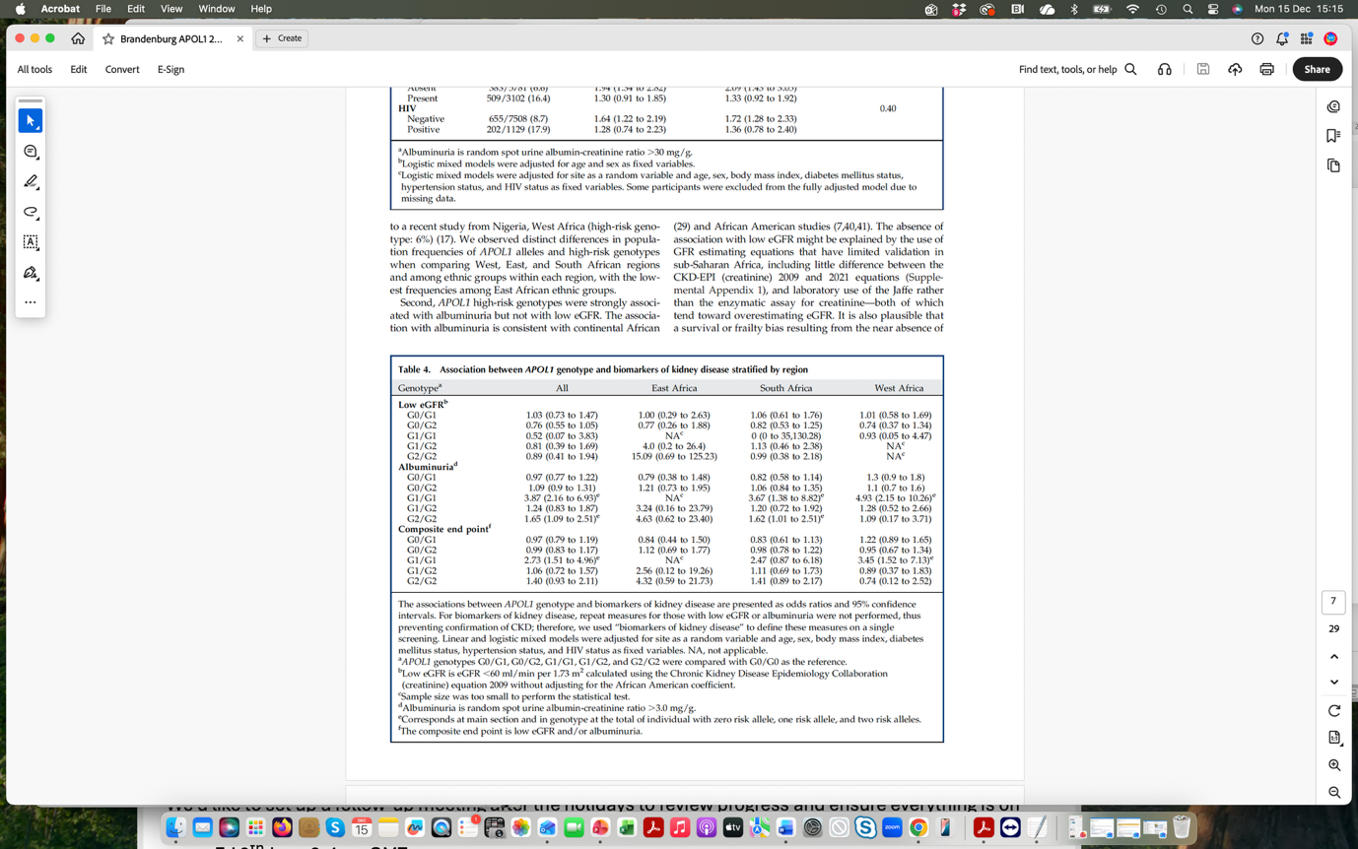

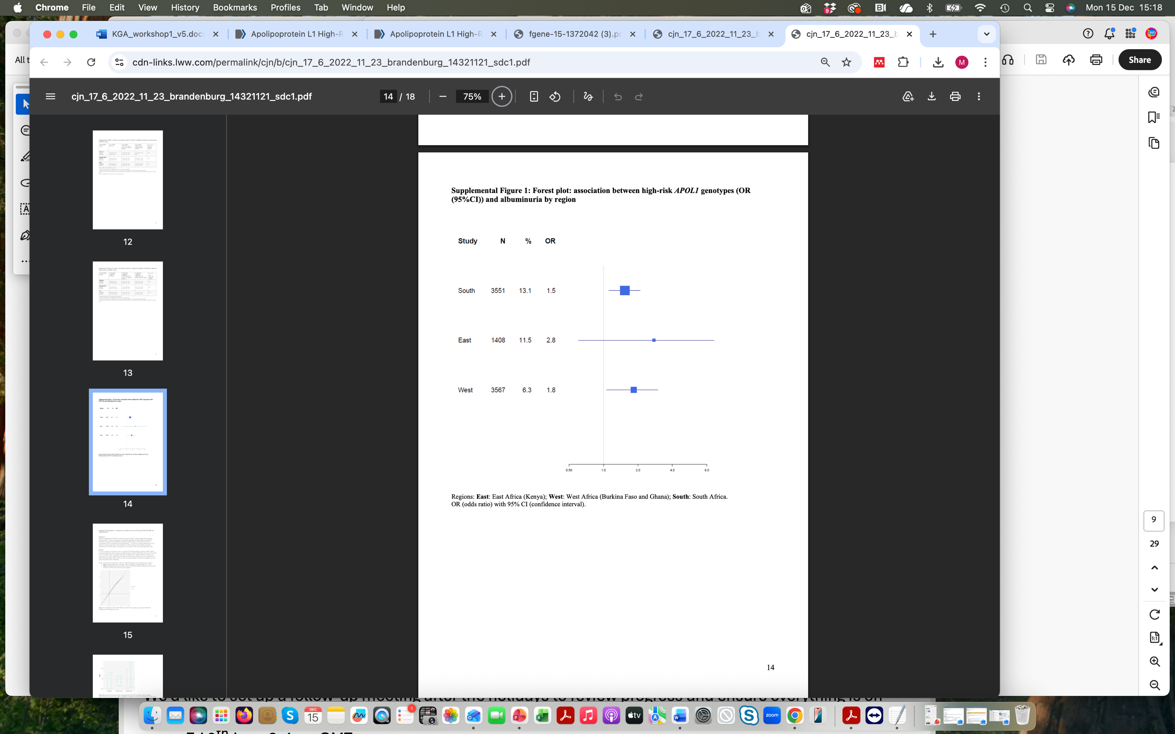

**Study 2:** Gbadegesin RA, et al. H3Africa Kidney Disease

Research Network. *APOL1* Bi- and Monoallelic Variants and Chronic Kidney

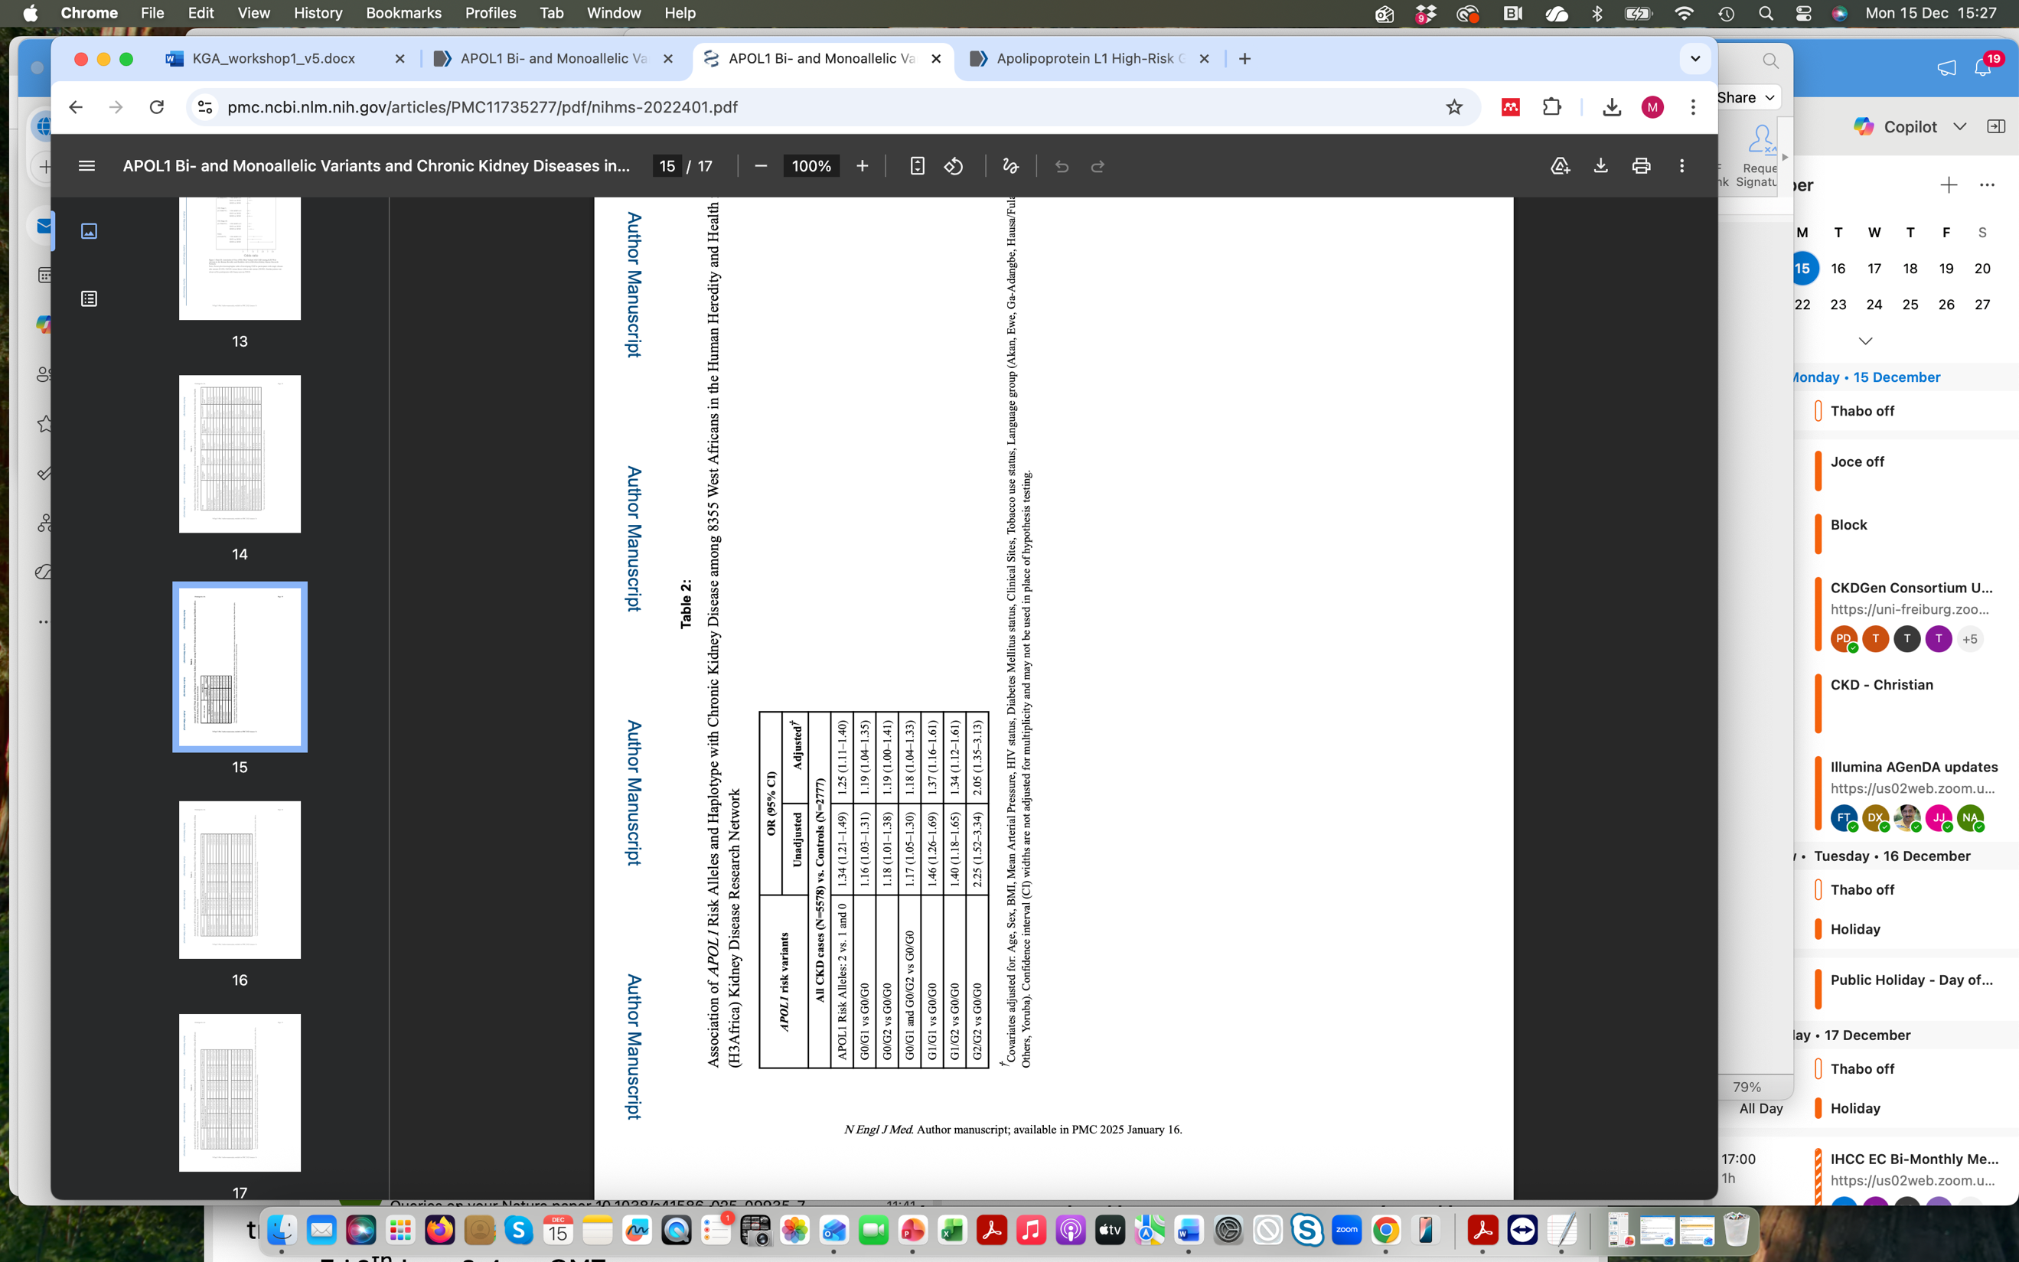Disease in West Africans. N Engl J Med. 2025 Jan 16;392(3):228-238. doi:

10.1056/NEJMoa2404211. Epub 2024 Oct 26. PMID: 39465900; PMCID: PMC11735277.

Associations of *APOL1* Risk Alleles and CKD among 8355 West Africans in the H3Africa Kidney Disease research network (covariates: Age, sex, BMI, MAP, HIV status, diabetes, clinical site, tobacco use and language group)

Questions:

1. What conclusions can you draw about genotype frequencies in different African populations?
2. Are the associations with the genotypes/haplotype or with the alleles?
3. Is the *APOL1* risk genotype causal of chronic kidney disease? Motivate you response
4. Do G1 and G2 contribute equally to the kidney function phenotype?